**VISVESVARAYA TECHNOLOGICAL UNIVERSITY**

JNANA SANGAMA, BELAGAVI -590 018

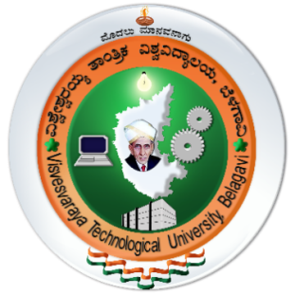

**A Mini-Project Report on**

**FEASIBILITY STUDY OF PARAMETERS FOR METRO CONSTRUCTION**

**A mini project submitted in the partial fulfillment for the award of the degree**

**BACHELOR OF ENGINEERING IN CIVIL ENGINEERING  
SUBMITTED BY**

**DURGESH SHAH 1AY22CV007**

**MONIKA SAH 1AY22CV012**

**SUVASH YADAV 1AY22CV020**

**SARTHAK YADAV 1AY22CV017**

**Under the Guidance of**

**Prof. Santosh. R**

**Asst. Prof.**

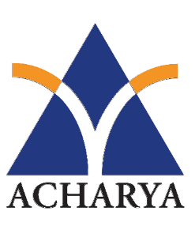**Department of Civil Engineering**

**2024-2025**

**DEPARTMENT OF CIVIL ENGINEERING**

**ACHARYA INSTITUTE OF TECHNOLOGY**

#### Acharya Dr. SarvepalliRadhadrishnan Road, Soladevanahalli, Bengaluru-560107

ACHARYA INSTITUTE OF TECHNOLOGY

Hesaraghatta Road, Dr. Sarvepalli Radhakrishnan Road

Bengaluru 560107  
DEPARTMENT OF CIVIL ENGINEERING.



CERTIFICATE

Certified that the Mini-Project entitled **“Feasibility study of parameters for metro construction”** is carried out by **Durgesh Shah (1AY22CV007), Monika Sah (1AY22CV012), Suvash Yadav (1AY22CV020) and Sarthak Yadav(1AY22CV017)**in the partial fulfillment for the award of the degree of Bachelor of Engineering in Civil Engineering of Visvesvaraya Technological University, Belagavi during the year **2024-2025**. It is certified that all corrections/suggestions indicated for the assessment have been incorporated in the report deposited in the departmental library. The Mini-Project Report has been approved as it satisfies the academic requirement in respect of the Mini-Project (22CV586) prescribed for the Bachelor of Engineering Degree.

…………………

Signature of Principal

Dr.Rajeshwari

Principal, AIT

…………………

Signature of HOD

Dr. P S. Niranjan

Head of the Department

Dept of Civil, AIT

…………………

Signature of Guide

Prof. Santosh. R

Asst. Prof.

Dept of Civil, AIT

**Name of the Examiners Signature with date**

**1**

**2**

**DECLARATION**

We the students of sixth semester Civil Engineering, Acharya Institute of Technology, Soladevanhalli Bengaluru -560107 declare that work entitled “FEASIBILITY STUDY OF PARAMETERS FOR METRO CONSTRUCTION” has been successfully completed under the guidance of PROF. SANTOSH. R, Department of Civil Engineering, Acharya Institute of Technology, Bengaluru. This dissertation work is submitted to Visvesvaraya Technological University in partial fulfilment of the requirements for the award of Degree of Bachelor of engineering In Civil Engineering during the academic year 2023-2024. Further the matter embodied in the mini-project report has not been submitted previously by anybody for the award of any degree or diploma to any university.

Place: Bengaluru

Date:20/12/2024

Mini-Project Group:

**Durgesh Shah 1AY22CV007**

**Monika Sah 1AY22CV012**

**Suvash Yadav 1AY22CV020**

**Sarthak Yadav 1AY22CV017**

ACKNOWLEDGEMENT

The satisfaction and euphoria that accompany the successful completion of a task would be incomplete without the mention of the people who made it possible and without their constant guidance and encouragement success would not have been possible.

I am grateful to the institute **Acharya Institute of Technology** and management for its ideas and inspiration for having provided us with the good infrastructure, laboratory, facilities, and inspiring staff which has made this Project work phase 1 successfully.

I would like to express my sincere gratitude to **Dr. Rajeshwari,** Principal, AIT, and **Prof. Mari Gowda C K,** Vice Principal, AIT for all the facilities that have been extended to them throughout my work.

I heartily thank and express my sincere gratitude to **Dr. P S. Niranjan,** Professor and HOD, Department of Civil Engineering, Acharya Institute of Technology for her valuable support and a constant source of enthusiastic inspiration to steer us forward.

I would like to express my sincere gratitude to the Internal Guide **Prof**. **Santosh. R,** Assistant Professor, Department of Civil Engineering, Acharya Institute of Technology for his/her invaluable guidance and support.

I would like to express my sincere gratitude to the Project Coordinator **Dr. T. Soumya,** Assistant Professor, Department of Civil Engineering, Acharya Institute of Technology for her valuable guidance and support.

Finally, I would like to express my sincere gratitude to my parents, all teaching and non-teaching faculty members, and friends for their moral support, encouragement, and help throughout the completion of the Project work.

**Durgesh Shah 1AY22CV007**

**Monika Sah 1AY22CV012**

**Suvash Yadav 1AY22CV020**

**Sarthak Yadav 1AY22CV017**

**ABSTRACT**

Surat, the second-largest city in Gujarat and a major hub for the diamond and textile industries, is witnessing rapid population growth and urbanization. With a metro area population exceeding 8 million and expanding development in its outskirts, the city faces challenges such as traffic congestion, vehicular pollution, and overburdened public transport systems. These issues are exacerbated by the lack of connectivity to remote regions and inadequate feeder systems for existing transportation networks.

The objective of this feasibility study is to evaluate the practicality of implementing a metro rail system in Surat as an alternative mode of transportation. The proposed metro system aims to offer a time-efficient, eco-friendly, and sustainable solution to the city's mobility needs. By using advanced tools like GIS and Global Mapper, the study identifies optimal metro routes based on traffic patterns and demand forecasts. The shortest feasible metro alignments are mapped to ensure minimal land use and environmental disruption while maximizing accessibility and operational efficiency.

A comprehensive cost-benefit analysis has been conducted to evaluate the economic and environmental trade-offs of the proposed system. This includes assessing construction costs, operational expenses, and long-term benefits such as reduced travel time, improved air quality, and job creation. The study also focuses on sustainability measures, including energy-efficient operations and the use of environmentally friendly construction materials.

The results highlight the potential of the Surat Metro system to transform urban mobility, alleviate traffic congestion, and contribute to the city's long-term sustainable development. By addressing key urban challenges and fostering economic growth, the metro project represents a significant step toward building a modern, accessible, and resilient transport network in Surat.

**INTRODUCTION**

Surat, located in the western Indian state of Gujarat, is one of the fastest-growing cities in the country. Known as the hub for the diamond and textile industries, it has a significant role in India’s economy. With a population exceeding 8 million and an urban area of 462.15 square kilometers, the city is experiencing rapid growth in both population and infrastructure demands.

The Surat Metro Rail Project is a proposed solution to address the challenges of increasing urbanization, vehicular congestion, and pollution in the city. Phase 1 of the project includes two metro corridors with a combined length of 40.35 kilometers. Corridor 1 will connect Sarthana to Dream City with 20 stations, while Corridor 2 will connect Bhesan to Saroli with 18 stations. These corridors are designed to improve connectivity across the city and its outskirts, ensuring better accessibility for residents and visitors.

The feasibility study for the Surat Metro focuses on assessing critical factors such as demand and alignment analysis, technical feasibility, economic viability, environmental and social impacts, and regulatory compliance. The study integrates modern tools like GIS and Global Mapper to map routes, analyze traffic patterns, and identify the shortest feasible alignments.

By addressing challenges such as overcrowding in existing public transit systems, increasing vehicular traffic, and limited connectivity to developing areas, the Surat Metro aims to offer a sustainable, efficient, and eco-friendly mode of transport. The project is not only a response to Surat’s current needs but also a step toward future-proofing the city’s infrastructure against rapid growth and urbanization.

**LITERATURE SURVEY**

**Objectives of the Literature Survey**

1. To gather insights from existing feasibility studies conducted for metro projects in other cities.
2. To identify the tools, methodologies, and key parameters evaluated in similar projects.
3. To analyze the challenges and solutions documented in prior research to better inform the current feasibility study.
4. To align the feasibility framework with the Metro Rail Policy, 2017, and other relevant guidelines.

**Key Insights from Literature Survey**

|  |  |
| --- | --- |
| **Source** | **Key Findings** |
| **Feasibility Study of Metro Transport: Case Study Madurai** | Identified cost-benefit analysis as a critical tool for evaluating economic viability and environmental impacts. |
| **IRJET Feasibility Studies (Nagpur and Others)** | Highlighted the importance of integrating sustainability measures and advanced tools like GIS for route optimization. |
| **Metro Rail Policy, 2017** | Provided a structured framework for planning, funding, and implementing metro projects with public-private partnerships. |
| **Other Case Studies (Ahmedabad and Delhi)** | Emphasized the need for traffic volume counts and demographic studies to predict ridership and optimize metro design. |

**Key Parameters Identified in Literature**

The literature survey underscored the importance of assessing the following parameters:

* **Economic Viability**: Cost-benefit analysis, funding sources, and long-term financial sustainability.
* **Environmental Impact**: Pollution reduction, energy efficiency, and biodiversity conservation.
* **Social Benefits:** Improved accessibility, job creation, and minimized community displacement.
* **Technical Feasibility**: Assessment of metro alignments, station design, and integration with existing transport systems.

**Challenges Highlighted**

1. **Land Acquisition and Compensation:**
   * Ensuring fair compensation and minimal displacement during construction phases.
2. **Traffic Disruptions:**
   * Mitigating disruptions during construction, especially in high-density urban areas.
3. **Cost Overruns:**
   * Addressing potential delays and budgetary constraints due to unforeseen challenges.

**PROBLEM DEFINITION**

Surat, one of India’s fastest-growing cities, faces significant urban transportation challenges due to its rapid population growth and expanding industrial base. The following key issues underline the need for an advanced transit system like the metro rail:

**1. Population and Employment Growth**

Surat's population is increasing at a rapid pace, with over 8 million residents in its metropolitan area. The city's role as a hub for the diamond and textile industries attracts a substantial workforce, further intensifying the demand for reliable transportation. The current infrastructure struggles to meet the mobility needs of both residents and commuters, leading to inefficiencies and delays.

**2. Vehicular Growth and Traffic Congestion**

The growing number of private vehicles on Surat’s roads has resulted in severe traffic congestion, especially during peak hours. With vehicle density steadily rising, the strain on existing road networks is unsustainable. Traffic congestion not only wastes time but also increases fuel consumption, leading to economic and environmental costs.

**3. Pollution and Environmental Impact**

The surge in vehicular traffic has escalated air pollution levels, contributing to deteriorating air quality and public health concerns. Emissions from vehicles are a major source of greenhouse gases in the city, necessitating a shift to more sustainable and eco-friendly transportation options.

**4. Lack of Connectivity to Outskirts**

While Surat’s central areas are relatively well-connected, its outskirts and developing regions face significant transportation gaps. Many areas lack efficient public transport, isolating residents and limiting access to economic opportunities. This lack of connectivity also hampers balanced urban development across the city.

**5. Inadequate Public Transportation Systems**

Existing transit systems, such as the Bus Rapid Transit System (BRTS) and Sitilink, are still in their developmental stages and lack sufficient feeder networks. The absence of a comprehensive, well-integrated public transport system has led to overcrowding and inefficiencies in service delivery.

**6. Rising Accident Rates**

The combination of high vehicular density and inadequate road infrastructure has led to an increase in road accidents. Without a reliable alternative mode of transport, the risk to commuter safety continues to grow, emphasizing the urgent need for a safe and dependable transit system.

**7. Challenges in Current Solutions**

Measures like flyovers and the expansion of road networks have provided temporary relief but fail to address the root causes of traffic congestion and connectivity issues. Without a long-term solution like a metro rail system, these challenges will continue to worsen as Surat’s population and economic activity grow.

**OBJECTIVES OF THE STUDY**

The feasibility study for the Surat Metro project aims to address pressing urban transportation challenges while paving the way for sustainable development. The objectives are aligned with the city’s current needs and future demands, ensuring that the proposed metro system benefits all stakeholders. Below is a detailed explanation of the key objectives:

**1. To Study the Solutions for Metro Rail Feasibility**

The primary objective of this study is to identify and evaluate the feasibility of implementing a metro rail system in Surat. This includes analyzing alternative routes, modes of operation, and integration with existing infrastructure to ensure technical, economic, and environmental viability. The goal is to propose solutions that are practical, cost-effective, and efficient.

**2. To Identify Existing Issues Related to Passengers**

The study focuses on understanding the current challenges faced by commuters, such as overcrowded public transport, long travel times, poor connectivity, and safety concerns. By identifying these issues, the project aims to provide tailored solutions to enhance the overall commuting experience and improve accessibility across the city.

**3. To Propose New Metro Routes Based on Demand**

A critical aspect of the study is to identify and design new metro routes that align with current and projected demand patterns. The study employs advanced tools like GIS and Global Mapper to map traffic flow, population density, and ridership trends. These routes aim to connect major hubs, residential areas, and underserved outskirts, ensuring balanced urban development.

**4. To Reduce the Burden on Existing Transit Systems**

The study aims to alleviate the pressure on Surat’s overburdened public transportation systems, such as the BRTS and Sitilink networks. By introducing the metro as an alternative mode of transport, the project seeks to decongest roads, reduce travel times, and enhance the reliability of urban mobility systems.

**5. To Conduct Surveys and Understand Passenger Preferences**

Understanding the needs and preferences of local commuters is central to the study. Surveys are conducted to gather insights on passenger expectations, preferred travel modes, affordability, and willingness to adopt the metro. This ensures that the proposed metro system is user-centric and widely accepted by the public.

**6. To Suggest Solutions for Current and Future Needs**

The study emphasizes forecasting future urban transportation needs based on historical data, demographic trends, and projected city growth. Solutions are proposed not only for existing challenges but also for future demands, ensuring that the metro system remains relevant and scalable as the city evolves.

**7. To Provide Sustainable and Forward-Thinking Solutions**

Sustainability is a cornerstone of the study. The proposed metro system integrates energy-efficient technologies, eco-friendly construction methods, and environmentally sustainable operations. The study aims to reduce the city’s carbon footprint while enhancing community well-being and economic performance.

**MATERIALS AND TOOLS**

The feasibility study for the Surat Metro project utilized a wide array of materials and tools to ensure a comprehensive and data-driven evaluation. These resources span across data collection, technical analysis, regulatory frameworks, and financial assessments to cover all aspects of metro construction feasibility. Below is a detailed overview of the materials and tools used:

**1. Data Sources and Documentation**

To understand existing conditions and forecast future requirements, the study relied on various data sources, including:

* **Historical Transportation Data:** Patterns of mobility and traffic volume in Surat.
* **Demographic and Population Data:** Census information and projected growth trends to estimate ridership demand.
* **Land Use Maps:** Maps detailing urban zoning, land availability, and existing infrastructure.
* **Environmental Impact Assessments (EIAs):** Studies on the ecological effects of metro construction, including air quality, noise, and biodiversity.

**2. Technical Reports**

Detailed technical documents and specifications were critical in assessing construction feasibility. Key components include:

* **Geotechnical Studies:** Analysis of soil and rock conditions to ensure safe construction of underground and elevated structures.
* **Engineering Designs:** Preliminary and detailed designs of metro routes, stations, and supporting infrastructure.
* **Cost Estimation Reports:** Projections of construction, operational, and maintenance expenses for the project.

**3. Legal and Regulatory Framework**

The project adhered to national and state laws to ensure compliance and minimize risks. Key legal tools include:

* **Zoning Laws and Regulations:** Ensuring that the metro aligns with Surat’s urban planning guidelines.
* **Environmental Regulations:** Adherence to standards set by the Gujarat Pollution Control Board (GPCB) and the Environmental Protection Act, 1986.
* **Safety Standards:** Compliance with Bureau of Indian Standards (BIS), particularly for seismic safety (Surat is in Seismic Zone III).
* **Acts and Guidelines:** Right to Fair Compensation and Transparency in Land Acquisition Act, 2013: Ensures fair land acquisition.
* **Building Codes:** Specifies construction standards for metro systems.

**4. Visualization and Analytical Tools**

Modern tools and techniques were employed for data visualization and decision-making, including:

* **Geographic Information Systems (GIS):** Used for mapping metro routes, analyzing spatial data, and optimizing alignments.
* **Global Mapper:** A tool for processing and visualizing geographic data to identify feasible routes with minimal disruption.
* **Graphs and Charts:** To visualize data trends, such as ridership forecasts, cost allocations, and environmental impact.

**5. Case Studies and Comparative Analyses**

Insights were drawn from existing metro projects in India and globally to understand best practices and potential pitfalls:

* Feasibility studies of metro systems in cities like Nagpur, Madurai, and Ahmedabad were referenced.
* Comparative analysis helped evaluate the applicability of these studies to Surat’s unique urban challenges.

**6. Financial and Economic Tools**

Robust financial tools were utilized to assess the economic viability of the project, such as:

* **Budget Estimates:** Comprehensive financial breakdown of construction, land acquisition, and operational costs.
* **Funding Sources:** Analysis of public-private partnerships (PPPs), government grants, and international loans.
* **Cost-Benefit Analysis:** A tool to weigh the economic benefits (e.g., reduced travel time, job creation) against the costs.

**7. Metro Rail Policy, 2017**

The Metro Rail Policy, 2017, provided a framework for project planning, funding mechanisms, and technical guidelines. It served as a benchmark to ensure the project adhered to national standards and best practices.

**METHODOLOGY USED FOR THE STUDY**

The methodology adopted for the feasibility study of the Surat Metro project is structured to evaluate the technical, economic, environmental, and social aspects of the metro system. The process involves systematic data collection, analysis, and decision-making to ensure a well-informed and sustainable proposal. Below is a detailed explanation of the steps involved:

**1. Data Collection**

The study began with extensive data collection to gather insights into Surat’s existing transportation infrastructure, population trends, and land use. The data sources included:

* Traffic volume studies to understand current patterns and peak hour congestion.
* Demographic data to analyze population density and projected growth.
* Existing transport systems like BRTS, Sitilink, and road networks.
* Environmental assessments to evaluate air quality, biodiversity, and noise levels.
* Legal and regulatory documents for compliance with zoning, safety, and environmental standards.

**2. Traffic and Demand Analysis**

This step involved assessing the current and future transportation demand in Surat:

* **Traffic Volume Counts (TVC):** Traffic patterns were studied at major arterial roads and intersections to estimate potential ridership and identify heavily congested corridors.
* **Travel Patterns:** Travel routes, peak travel hours, and passenger demographics were analyzed to predict ridership trends.
* **Demand Forecasting:** Tools such as the Least Square Method were applied to project the future demand for metro services based on population and economic growth.

**3. Application of Analytical Models**

Two analytical approaches were used to guide decision-making:

* **Least Square Method:** This statistical technique was applied to forecast passenger growth and transportation needs over time by analyzing historical data.
* **Analytic Hierarchy Process (AHP):** A multi-criteria decision-making tool was used to prioritize metro routes, station locations, and design options. The process included:
  + Establishing a hierarchy of goals, criteria, and alternatives.
  + Comparing alternatives against criteria such as cost, environmental impact, ridership, and technical feasibility.
  + Selecting the best alignment and design.

**4. Location and Alignment Analysis**

The alignment of the metro network was determined based on:

* **City Profile Analysis:** Examination of Surat’s urban layout, land use patterns, and existing infrastructure.
* **Route Mapping:** Advanced tools like GIS and Global Mapper were used to identify the shortest and most feasible metro routes, minimizing land acquisition and environmental disruption.
* **Corridor Selection:** Two corridors were identified:
  + **Corridor 1**: Sarthana to Dream City, with 20 stations (14 elevated, 6 underground).
  + **Corridor 2:** Bhesan to Saroli, with 18 fully elevated stations.

**5. Technical Feasibility Analysis**

This step focused on assessing the structural and operational requirements:

* **Alignment Options:** Underground, elevated, and at-grade options were evaluated based on topography and urban constraints.
* **Station Design:** Consideration of station locations, accessibility, and integration with existing transport systems.
* **Structural Feasibility:** Geotechnical studies and engineering designs were reviewed to ensure stability and safety.

**6. Financial and Economic Analysis**

A thorough economic evaluation was conducted to assess the project’s viability:

* **Cost Estimation:** Construction, operational, and maintenance costs were calculated, including materials, labor, land acquisition, and signaling systems.
* **Funding Analysis:** Potential funding sources were identified, including government grants, public-private partnerships (PPPs), and international loans.
* **Cost-Benefit Analysis:** The benefits of the metro, such as reduced travel time, pollution reduction, and job creation, were compared to the costs to establish economic feasibility.

7. Environmental and Social Impact Assessment

This step analyzed the broader implications of the metro project:

* **Environmental Impact:** Pollution reduction, noise mitigation, and biodiversity conservation measures were proposed. Sustainability practices, such as energy-efficient systems, were also incorporated.
* **Social Impact:** The project’s effects on job creation, accessibility, and displacement of communities were evaluated to ensure a balance between development and social equity.

**8. Legal and Regulatory Compliance**

The project’s adherence to legal and regulatory standards was ensured:

* **Land Acquisition Laws:** Compliance with the Right to Fair Compensation and Transparency in Land Acquisition Act, 2013.
* **Environmental Laws:** Adherence to the Environment Protection Act, 1986 and Gujarat-specific guidelines.
* **Safety Standards:** Incorporation of seismic safety measures in design and construction (Surat is in Seismic Zone III).

**9. Integration of Sustainability and Affordability**

The methodology included strategies to ensure:

* **Sustainability:** Implementation of eco-friendly technologies and minimal environmental disruption.
* **Affordability**: Financial accessibility for all, with subsidized fares for economically weaker sections and efficient cost management.

**KEY PARAMETERS**

The feasibility of the Surat Metro project was assessed using several critical parameters to ensure the project meets technical, economic, social, and environmental goals. Below is a detailed explanation of each parameter, along with a summary in tabulated format.

**1. Location and Demand Assessment**

This parameter evaluates the geographical and demographic suitability of the metro system:

* **Existing Transport Characteristics**: Analyzed the current infrastructure, including BRTS and road networks.
* **Population Density and Growth:** Forecasted ridership based on demographic trends and projected urban growth.
* **Travel Patterns:** Studied peak hours, route preferences, and passenger demographics to design efficient metro routes.

**2. Traffic Volume Counts (TVC)**

* **Objective:** Understand traffic patterns to estimate potential metro ridership.
* **Method:** Traffic volume counts were conducted at major arterial roads and intersections to measure passenger and vehicle density.
* **Outcome:** Identified corridors with high congestion levels, which were prioritized for metro alignment.

**3. Technical Feasibility**

* **Metro Alignment Options:** Evaluated underground, elevated, and at-grade alignments.
* **Structural Requirements:** Assessed tunneling feasibility, station locations, and integration with existing transportation systems.
* **Integration:** Focused on seamless connectivity with other transport modes like buses and feeder networks.

**4. Financial and Economic Feasibility**

* **Cost Estimation:** Included construction, operational, and maintenance costs.
* **Funding Sources:** Identified government funding, PPP models, and international loans.
* **Cost-Benefit Analysis:** Weighed benefits like reduced travel time, economic development, and job creation against costs.

**5. Environmental Impact Feasibility**

* **Pollution Reduction:** Projected a significant drop in air pollution due to reduced vehicle use.
* **Noise Mitigation:** Proposed sound barriers and restricted construction hours to minimize impact on communities.
* **Biodiversity Management:** Suggested reforestation and habitat restoration efforts.

**6. Social Impact Feasibility**

* **Job Creation:** Estimated up to 10,000 jobs post-operation.
* **Improved Accessibility:** Increased public transport coverage from 50% to 90%.
* **Minimized Displacement:** Reduced community displacement from 10% to 5% through better planning.

**7. Legal and Regulatory Compliance**

* **Land Acquisition:** Ensured fair compensation and minimal disruption.
* **Safety Standards:** Incorporated seismic safety measures (Surat is in Seismic Zone III).
* **Regulatory Approvals:** Adhered to environmental and urban development laws.

**8. Sustainability**

* **Eco-Friendly Technologies:** Incorporated solar energy and energy-efficient systems.
* **Resource Optimization:** Minimized environmental degradation while maximizing efficiency.
* **Long-Term Impact:** Promoted balanced urban growth and reduced dependency on fossil fuels.

**LOCATION AND DEMAND ASSESSMENT**

Surat, the second-largest city in Gujarat, is a key economic hub and one of India’s fastest-growing cities. With a population of over 8 million and a rapidly expanding urban area of 462.15 square kilometers, the city faces significant transportation challenges due to urbanization, increasing vehicular traffic, and the lack of efficient transit options. The Surat Metro aims to address these challenges by strategically evaluating the location and demand for the proposed metro network.

**Key Elements of Location and Demand Assessment**

**1. City Profile and Existing Transport Characteristics**

* Surat’s urban landscape includes a mix of densely populated areas and developing outskirts.
* The city’s existing transport network, including Bus Rapid Transit System (BRTS) and Sitilink, struggles to meet the mobility needs of a growing population.
* Rapid urban expansion has led to increased reliance on private vehicles, resulting in congestion and pollution.

**2.Ridership Projections Based on Demographics**

* The assessment considers population density, travel patterns, and projected population growth.
* Ridership forecasts are based on historical data and future trends, ensuring the metro network caters to both current and anticipated demands.
* Target demographics include commuters from residential zones, business hubs, and industrial areas.

**3.Travel Patterns and Target Demographics**

* Analysis of travel routes, peak-hour traffic, and commuter preferences.
* Focused on areas with high traffic volume and inadequate connectivity to optimize the placement of metro corridors and stations.

**Proposed Metro Corridors**

The Surat Metro Phase 1 includes two strategically designed corridors based on demand and location assessment:

* **Corridor 1 (Sarthana to Dream City)**
  + **Length**: 21.61 kilometers
  + **20 stations:** 14 elevated and 6 underground
  + Serves key residential and commercial hubs, providing relief to high-congestion zones.
* **Corridor 2 (Bhesan to Saroli)**
  + **Length:** 18.74 kilometers
  + **18 stations**: All elevated
  + Focuses on improving connectivity to the city’s outskirts and developing regions.

**Outcomes of the Location and Demand Assessment**

* **Increased Accessibility:** The metro network will connect densely populated areas and poorly served regions, ensuring equitable access to transportation.
* **Reduced Congestion:** By offering a reliable alternative to private vehicles, the metro will alleviate pressure on existing road networks and public transport systems.
* **Optimized Route Placement:** Advanced tools like GIS and Global Mapper were used to design the shortest and most efficient alignments, minimizing land acquisition and environmental impact.

The location and demand assessment provide a foundation for a metro system that aligns with Surat’s current needs and future growth, offering a sustainable solution to its transportation challenges.

**TRAFFIC VOLUME COUNT(TVC)**

The Traffic Volume Count (TVC) is a crucial component of the feasibility study for the Surat Metro project. It helps assess the current and projected traffic patterns in the city, enabling the identification of corridors with high congestion and determining the demand for metro services. By understanding the existing traffic dynamics, the TVC analysis informs the planning of metro routes, stations, and operational strategies.

**Key Aspects of Traffic Volume Counts (TVC)**

**1.Objective of Traffic Volume Counts**

* The primary goal of conducting TVC is to estimate ridership on potential metro corridors and understand traffic characteristics in terms of both vehicular and passenger volume.
* TVC helps identify the key areas of congestion, peak traffic hours, and areas that would benefit most from metro implementation.

**2.Methodology for TVC**

* TVC was conducted at various locations across Surat, particularly at major arterial roads and intersections that are likely to be included in the proposed metro alignments.
* These counts focused on both vehicular traffic and passenger flow, helping to understand how many people rely on these corridors for daily commuting.

**3.Traffic Characteristics Measured**

* **Vehicular Traffic:** The number of vehicles, types of vehicles (e.g., cars, buses, trucks), and traffic density during peak and off-peak hours were recorded.
* **Passenger Traffic:** Passenger counts at bus stops and key transit points were measured to understand current public transport demand.
* **Passenger Car Unit (PCU):** A unit of measurement that allows for the comparison of different types of vehicles (e.g., one bus might equal several cars in terms of road space). This was used to assess traffic density and predict metro ridership.

**4.Analysis and Identification of Congestion Areas**

* TVC results identified key corridors with the highest traffic volumes and congestion during peak hours, highlighting where metro corridors should be prioritized.
* Locations with persistent congestion, such as Sarthana, Dream City, Bhesan, and Saroli, were flagged for inclusion in the metro network.

**Outcome of Traffic Volume Counts (TVC)**

* **Identification of High-Demand Corridors:** The traffic volume counts helped pinpoint the busiest roads and intersections, ensuring that the proposed metro system would serve the areas with the greatest need for enhanced transportation.
* **Feasibility of Metro Alignment:** Based on TVC data, the proposed metro routes were optimized to serve the most congested areas, thereby alleviating pressure on existing transportation systems.
* **Improved Traffic Flow:** By introducing the metro, areas with the highest vehicular traffic can expect significant reductions in congestion, contributing to smoother and more efficient urban mobility.

**Visual Representation**

* **Traffic Volume Count Data:** Graphs and charts were used to illustrate the traffic volume across different corridors, providing a clear picture of the areas with the highest congestion. These visual tools also highlighted the peak hours and the distribution of vehicle types in these zones.

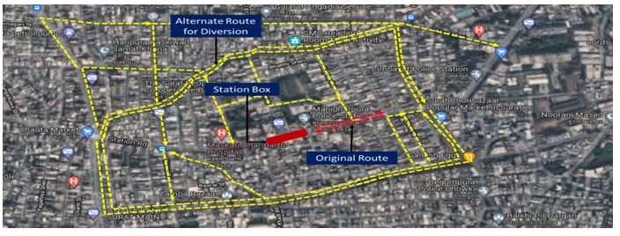

The TVC analysis played a pivotal role in identifying the areas most in need of metro service and ensured that the metro system would be implemented in locations where it could provide the greatest impact in terms of reducing congestion and improving mobility.

**TECHNICAL FEASIBILITY**

The Technical Feasibility of the Surat Metro project involves assessing the practical and structural aspects required for its successful implementation. This includes evaluating the alignment options, station locations, integration with existing transportation systems, and the overall design of the metro network to ensure its operational efficiency, safety, and sustainability.

**Key Aspects of Technical Feasibility**

**1.Metro Alignment Options**

* Elevated, Underground, and At-Grade Alignments: Different alignment options were considered based on the city’s topography, land availability, and urban development patterns.
  + **Elevated:** Chosen for areas with high population density and limited space for underground construction. These structures are less disruptive during construction and ensure efficient land use.
  + **Underground:** Selected for congested city centers where surface space is limited or where elevated structures would disrupt urban life.
  + **At-Grade**: Used in areas with lower population density and where roadways can be utilized efficiently for metro tracks without major modifications.

**2.Structural Requirements**

* **Station Locations and Design:** The metro stations are strategically planned at key intersections and transportation hubs to maximize accessibility. The design includes provisions for both passenger flow and safety, with adequate space for future expansions.
* **Structural Integrity:** Detailed geotechnical studies were conducted to assess the suitability of soil and rock conditions for constructing elevated and underground stations. These studies ensure that the proposed alignments and stations are structurally sound and can withstand environmental stresses.

**3.Integration with Existing Transportation Systems**

* The metro network was designed to integrate seamlessly with Surat’s existing transport infrastructure, such as the BRTS and Sitilink, as well as future feeder bus routes.
* **Intermodal Connectivity:** Stations are planned to connect with existing public transport services, enabling smooth transitions for passengers from one mode of transport to another.

**4.Technological Considerations**

* **Signaling and Electrification:** Advanced signaling systems will be incorporated to ensure safe and efficient operations. The electrification of metro trains will follow environmentally friendly standards to reduce carbon footprints.
* **Train Control Systems:** Automatic train control and monitoring systems will be implemented to optimize train schedules, reduce delays, and ensure passenger safety.

**5.Feasibility of Construction**

* **Construction Materials:** Sustainable and durable materials will be used for the construction of stations, tunnels, and elevated tracks.
* **Construction Methodology:** The construction process has been designed to minimize disruptions to existing urban activities. For example, elevated tracks require minimal road closures, while underground tunnels avoid surface disruption.
* **Timeframe and Phases:** The metro project will be implemented in phases, with the first phase focusing on building the initial corridors (Sarthana-Dream City and Bhesan-Saroli) before expanding further.

**Outcome of Technical Feasibility Analysis**

* **Optimal Route Selection:** The analysis confirmed that the proposed alignments, combining elevated, underground, and at-grade options, are the most suitable for Surat’s urban landscape and future growth.
* **Design Compatibility:** The metro system is designed to integrate smoothly with Surat’s existing infrastructure, ensuring efficient passenger transfers and minimizing potential disruptions to daily life.
* **Safety and Durability:** The structural assessments ensured that the project will be safe, sustainable, and capable of withstanding the environmental challenges posed by Surat’s diverse geography.

**Visual Representation**

**Metro Route Maps:** The proposed alignments for both metro corridors (Sarthana-Dream City and Bhesan-Saroli) are shown in detailed maps, highlighting elevated and underground sections.

**Station Layouts:** Diagrams of station designs, including entry/exit points, passenger flow paths, and integration with surrounding areas, were also part of the technical feasibility assessment.

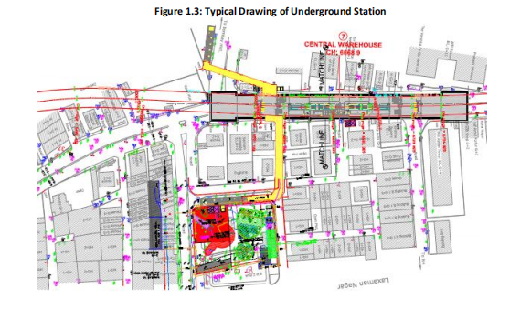

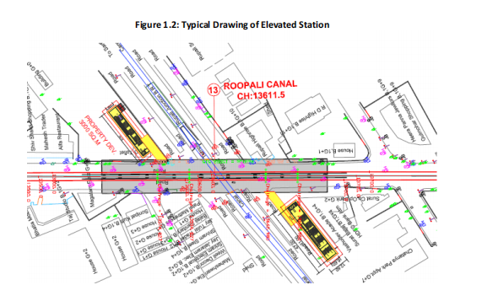

The technical feasibility study ensured that the Surat Metro project is both structurally and operationally viable, capable of meeting the city’s transportation needs in an efficient, safe, and sustainable manner. By combining advanced engineering techniques with careful planning, the project is set to deliver a metro network that can support Surat's future growth while providing a reliable, modern transportation option for its residents.

**FINANCIAL AND ECONOMIC FEASIBILITY**

The Financial and Economic Feasibility section evaluates the economic viability and financial sustainability of the Surat Metro project. This assessment includes an analysis of construction costs, funding sources, operational expenses, and the long-term economic benefits that the metro system will bring to the city. It also highlights cost-benefit analysis, providing a comprehensive view of the project's financial health.

**Key Aspects of Financial and Economic Feasibility**

**1.Cost Estimation**

* **Construction Costs:** The costs for building the metro system include the construction of tracks, stations, tunnels, and elevated structures. Additionally, expenses include purchasing metro trains, electrical systems, signaling infrastructure, and safety equipment.
* **Land Acquisition:** Significant costs are involved in acquiring land for stations, track alignments, and associated infrastructure. This includes compensating for right-of-way and dealing with any legal and regulatory requirements related to land acquisition.
* **Operational Costs:** The ongoing costs required for the operation of the metro system include labor costs, energy consumption, maintenance, security, and other administrative expenses. It also covers routine and emergency repairs to ensure continuous service.
* **Maintenance Costs:** These include the costs associated with the regular upkeep of stations, tracks, and trains, as well as asset replacement and infrastructure improvements over time.

**2.Funding Sources**

* **Government Funding:** The project will receive substantial funding from state and central government bodies to support its construction and initial operation. This is particularly important for public transport projects that provide social benefits.
* **Public-Private Partnerships (PPPs**): The Surat Metro project seeks to attract investment through PPPs, where private sector firms contribute to the funding and management of the system, while the government guarantees certain levels of performance and returns.
* **International Loans and Grants:** To supplement national funding, the project may also seek loans or grants from international organizations that support urban infrastructure development.
* **Revenue Generation:** The metro system will generate revenue through ticket sales, advertising, and leasing commercial space in and around stations. This will help offset operational costs and contribute to financial sustainability.

**3.Cost Allocation:**

A detailed breakdown of the cost allocation for the Surat Metro project is as follows:

* **Infrastructure Development**: Costs related to constructing stations, tracks, and other facilities.
* **Civil Works:** Costs for civil construction, including tunnels, elevated tracks, and station buildings.
* **Signaling and Electrification:** Investment in the technology required to operate the metro system efficiently and safely.
* **Purchase of Trains and Rolling Stock:** Costs of acquiring the trains and the necessary equipment to operate them.
* **Land Acquisition:** Compensation for right-of-way and land needed for the metro corridors and stations.
* **Operational Costs**: Labor, energy, security, and other ongoing costs necessary to keep the metro running smoothly.
* **Maintenance Costs:** Regular repairs, asset replacement, and routine upkeep.

**4.Economic Benefits:**

The Surat Metro is expected to deliver significant long-term economic benefits, including:

* **Reduced Travel Time:** The metro will significantly cut down travel time for commuters, leading to increased productivity and economic activity in the city.
* **Job Creation:** The construction and ongoing operation of the metro will create thousands of jobs, both directly (in the metro system itself) and indirectly (in sectors such as construction, security, and maintenance).
* **Economic Growth:** By improving connectivity, the metro will promote urban mobility and foster economic growth by facilitating better access to businesses, markets, and services.
* **Enhanced Property Value**: Areas around metro stations are likely to see an increase in property values, driving further economic development in the region.
* **Pollution Reduction:** By providing a cleaner and more efficient transport option, the metro will contribute to lower emissions and a healthier urban environment, reducing the costs associated with pollution-related health issues.

**Cost-Benefit Analysis**

* **Economic Internal Rate of Return (EIRR):** The Economic Internal Rate of Return (EIRR) for the Surat Metro is estimated to be 17.20%, indicating that the metro project is highly economically justified. The high EIRR reflects the substantial long-term benefits the metro will bring to the city's economy.
* **Benefit-to-Cost Ratio:** The benefit-to-cost ratio suggests that the returns on investment from the metro system will far outweigh the initial and ongoing costs, confirming its financial sustainability.

**Outcome of Financial and Economic Feasibility Analysis**

* **Justification of Investment:** The metro project is financially viable, with significant returns expected from reduced congestion, improved productivity, and increased property values.
* **Sustainability:** The combination of government funding, PPPs, and revenue generation from ticket sales and commercial opportunities makes the project financially sustainable over the long term.
* **Economic Growth:** The metro is expected to be a key driver of economic development in Surat, creating jobs and improving overall urban mobility, which in turn will benefit businesses and residents.

**Visual Representation**

* **Cost Allocation Pie Chart:** A pie chart depicting the distribution of costs for the metro system, showing the proportion allocated to infrastructure development, civil works, rolling stock, and other essential components.

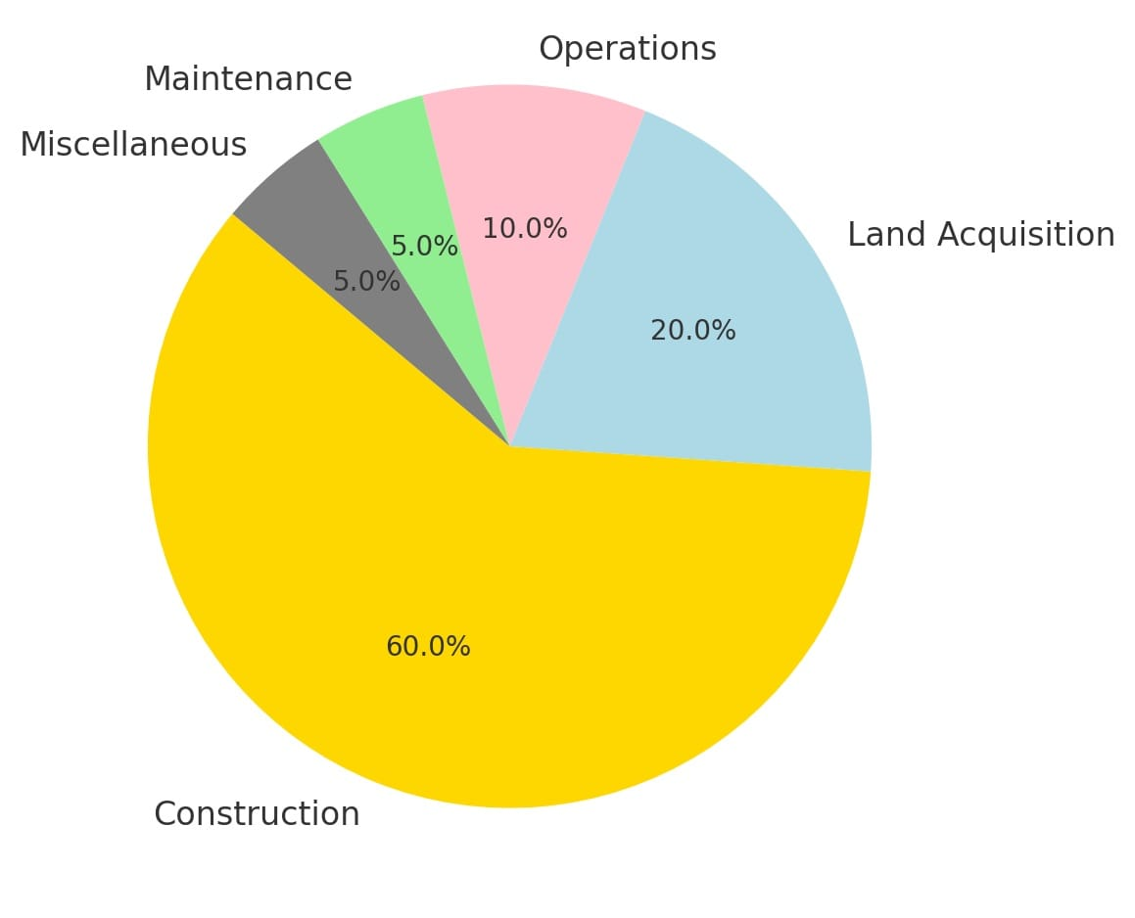

* **Revenue Generation Model:** Graphical representation of expected revenue streams, including ticket sales, advertising, and commercial leases around metro stations.

The Financial and Economic Feasibility analysis confirms that the Surat Metro is a sound investment, with strong potential for economic benefits that will continue to grow over time. The project’s long-term sustainability and significant positive impact on Surat’s economy further justify its development and implementation.

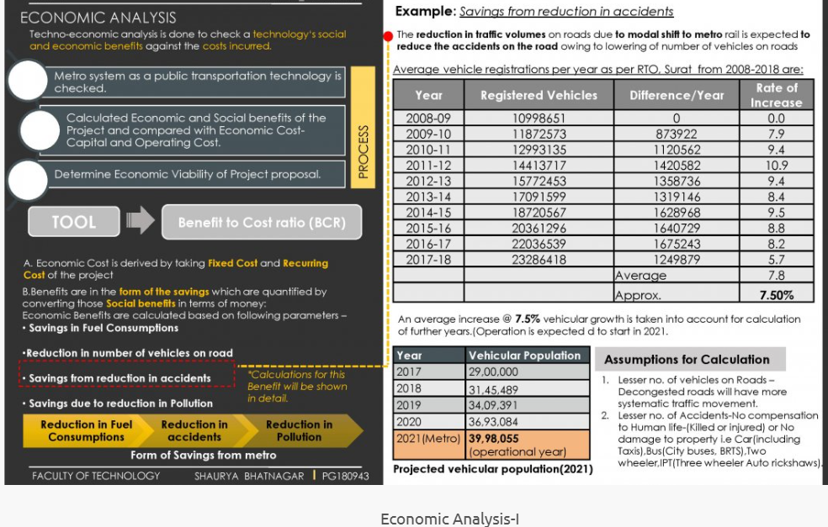

**ENVIRONMENTAL AND SOCIAL IMPACT FEASIBILITY**

The Environmental and Social Impact Feasibility section evaluates the potential effects of the Surat Metro project on the environment and the local community. This assessment is crucial for ensuring that the project not only meets its transportation goals but also contributes to sustainable urban development while minimizing adverse effects on both the environment and society.

**Key Aspects of Environmental and Social Impact Feasibility**

**1. Environmental Impact Feasibility**

The Surat Metro project is designed with sustainability in mind. The environmental impact assessment evaluates how the metro will affect air quality, noise levels, biodiversity, and other ecological aspects.

* **Pollution Reduction**
  + **Air Quality:** One of the primary environmental benefits of the metro is the reduction in vehicular emissions. The metro will significantly reduce the number of cars and buses on the road, leading to improved air quality and a decrease in greenhouse gas emissions.
  + **Noise Mitigation:** Construction and operation of the metro could generate noise pollution, especially in urban areas. However, measures such as sound barriers, restricted construction hours, and noise-reducing train technology are incorporated to minimize disruption to local communities.
  + **Pollution Reduction Visual Representation:** A pie chart shows that 40% of the environmental impact is focused on reducing vehicular pollution, which is a major source of air contamination in Surat.
* **Energy Efficiency**
  + **Solar Power:** The metro system will integrate energy-efficient technologies, including the use of solar power and other green technologies, to reduce overall energy consumption.
  + **Efficient Train Operations:** The design of the metro ensures minimal energy consumption during operations through regenerative braking systems and efficient train control.
* **Biodiversity Management**
  + **Habitat Restoration:** The project plans to mitigate the impact on local biodiversity by implementing reforestation and habitat restoration efforts. This will help preserve local flora and fauna that may be affected by the construction of metro corridors.
  + **Sustainability Practices:** The construction process will incorporate environmentally sustainable practices, such as reducing waste and minimizing disruptions to natural habitats.

**2. Social Impact Feasibility**

The social impact of the metro system on Surat’s residents is equally important. The metro will bring numerous benefits to the city’s population but also requires careful consideration of its social consequences, such as job creation, community displacement, and access to transportation.

* **Job Creation**
  + **Construction Phase:** The metro project will create approximately 2,000 jobs during the construction phase, including labor for civil works, engineering, and installation of tracks and systems.
  + **Post-Operational Jobs:** After the metro is operational, an estimated 10,000 jobs will be created, including metro operations, station management, security, maintenance, and ancillary services related to the metro.
* **Improved Accessibility**
  + **Access to Public Transport:** Currently, only 50% of Surat’s population has reliable access to public transport. The metro will increase this coverage to 90%, significantly improving access for underserved communities, especially in the outskirts of the city.
  + **Connectivity and Equity:** The metro network will connect residential areas to business hubs, industrial areas, and important services, ensuring greater social inclusion for the city's residents.
* **Community Displacement and Compensation**
  + **Minimizing Displacement:** The metro project plans to minimize displacement by carefully planning station locations and alignments. Initially, 10% of the population in affected areas may face displacement due to the project. However, through improved planning and compensation strategies, this number is expected to be reduced to 5%.
  + **Fair Compensation:** For those displaced, the project will ensure fair compensation and support according to the Right to Fair Compensation and Transparency in Land Acquisition Act, 2013, ensuring that no community is unduly burdened by the development.
* **Social Displacement Visual Representation:** A bar graph illustrates the decrease in social displacement, from 10% initially, to 5% post-planning due to careful urban and land-use planning.

**Outcome of Environmental and Social Impact Feasibility**

* **Environmental Sustainability:** The metro project will significantly reduce urban pollution, promote the use of clean energy, and contribute to the long-term health of Surat’s environment.
* **Community Benefits:** The metro will greatly enhance accessibility, create thousands of jobs, and improve the quality of life for Surat’s residents by offering a sustainable, reliable, and affordable transport option.
* **Social Equity:** Efforts to minimize displacement, provide compensation, and ensure fair access to transportation will make the project socially inclusive and beneficial for all sections of society.

**Visual Representation**

**Pollution Reduction:** A pie chart showing that 40% of the environmental impact is focused on pollution reduction, followed by noise mitigation (25%), energy efficiency (20%), and biodiversity loss management (15%).

**Social Impact:** A bar graph illustrating job creation during the construction and operational phases, as well as improvements in accessibility and the reduction in community displacement.

The Environmental and Social Impact Feasibility analysis demonstrates that the Surat Metro project is not only technically and economically viable but also environmentally sustainable and socially beneficial. The project is designed to minimize its ecological footprint while maximizing its positive effects on public health, urban mobility, and social equity.

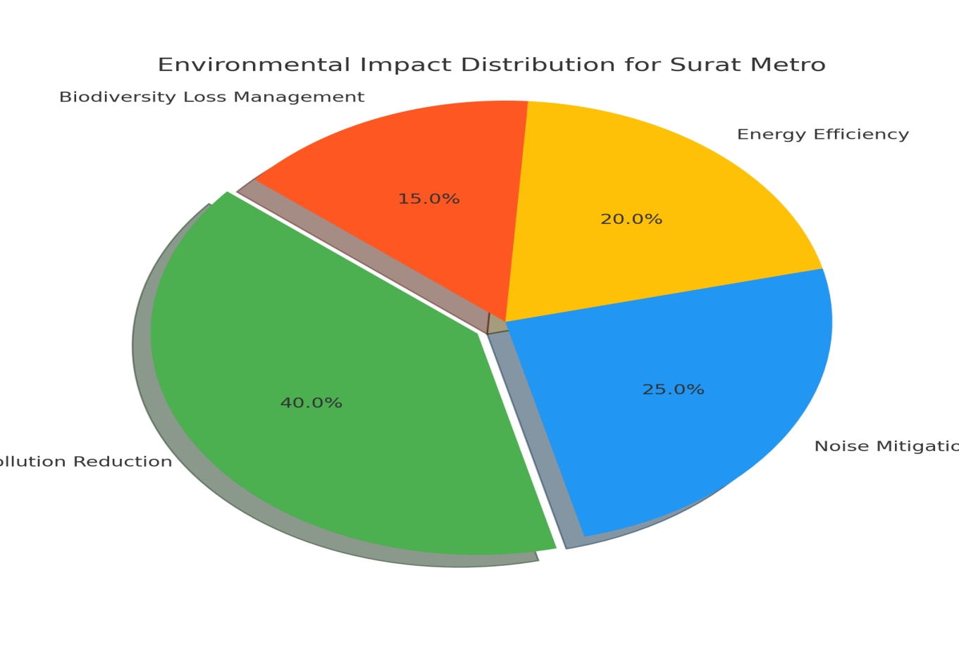

**LEGAL AND REGULATORY FEASIBILITY**

The Legal and Regulatory Feasibility section evaluates the compliance of the Surat Metro project with local, regional, and national laws, regulations, and policies. Ensuring that the project adheres to legal frameworks is critical for securing approvals, mitigating risks, and ensuring smooth execution. This section outlines the necessary legal steps and regulatory requirements for the successful implementation of the metro system.

**Key Aspects of Legal and Regulatory Feasibility**

**1.Zoning and Land Use Compliance**

* **Gujarat Town Planning and Urban Development Act**: The metro project must comply with Surat’s urban planning regulations to ensure minimal disruption to the existing urban layout. The proposed metro alignments will be evaluated to ensure that they do not conflict with the city's zoning laws or land use plans.
* **Land Acquisition:** The metro system requires land acquisition for stations, tracks, and ancillary infrastructure. The project will adhere to the Right to Fair Compensation and Transparency in Land Acquisition Act, 2013, which guarantees fair compensation for land owners and ensures that the process is transparent and equitable.

**2.Environmental Compliance**

* **Environmental Impact Assessment (EIA):** Before proceeding with the construction of the metro, an Environmental Impact Assessment (EIA) will be conducted to evaluate the potential environmental impacts of the project. This includes air quality assessments, noise impact studies, and ecological evaluations to ensure that the metro aligns with the Environment Protection Act, 1986.
* **Approvals from Regulatory Authorities**: The project must obtain approvals from relevant authorities, such as the Gujarat Pollution Control Board (GPCB), to ensure that environmental guidelines are met during the construction and operation of the metro

**3.Safety and Building Code Compliance**

* **Bureau of Indian Standards (BIS):** The metro system will adhere to the safety standards set by the Bureau of Indian Standards (BIS). These regulations cover structural safety, electrical systems, fire safety, and general passenger safety, ensuring that the metro operates securely for all commuters.
* **Seismic Safety Standards:** Surat is located in Seismic Zone III, meaning that the metro must comply with seismic safety regulations to ensure the structural integrity of elevated and underground tracks and stations in the event of an earthquake. The project will incorporate design features that minimize seismic risks, in accordance with national safety standards.

**4.Land Acquisition and Compensation**

* **Land Acquisition Act, 2013:** This act ensures that any land required for the metro project is acquired with full transparency and that affected individuals receive fair compensation for their property. It also includes provisions for rehabilitation and resettlement of displaced persons.
* **Compensation Mechanism:** For landowners affected by the construction of the metro system, a structured compensation and resettlement plan will be put in place, ensuring they are adequately compensated for the loss of their land and property.

**5.Regulatory Approvals and Permits**

* **National and State Approvals:** The project will require various approvals and permits from both national and state agencies. These include permissions related to land use, construction, safety standards, and environmental clearances. A key part of the process will be securing clearances from the Ministry of Environment and Forests and the Gujarat Urban Development Corporation (GUDC).
* **Metro Rail Policy, 2017:** The Surat Metro project is guided by the Metro Rail Policy, 2017, which provides the regulatory framework for metro development in India. This policy outlines the procedures for planning, funding, construction, and operation of metro systems, ensuring that all legal, technical, and financial standards are met.

**Outcome of Legal and Regulatory Feasibility Analysis**

* **Compliance with Local and National Regulations:** The project aligns with Surat’s urban planning regulations and complies with all necessary legal frameworks, ensuring minimal legal challenges during the construction and operation phases.
* **Environmental and Safety Standards:** The metro system will meet all required environmental and safety standards, ensuring the protection of both the environment and the public.
* **Fair Compensation and Land Acquisition:** The project has a clear plan for land acquisition that ensures fair compensation to affected parties, in line with the Right to Fair Compensation and Transparency in Land Acquisition Act, 2013.
* **Approval Process**: All necessary approvals and permits will be obtained before the start of construction, ensuring that the metro system is legally authorized to proceed without delays.

The Legal and Regulatory Feasibility analysis confirms that the Surat Metro project is in full compliance with all relevant legal and regulatory frameworks. This ensures a smooth implementation process, minimizes potential legal risks, and guarantees that the project meets environmental, safety, and urban planning standards.

**SUSTAINABILITY**

The Sustainability section focuses on the long-term environmental, economic, and social benefits of the Surat Metro project. It evaluates how the metro system will contribute to sustainable urban mobility, minimize its environmental footprint, and promote social equity and economic development. Sustainable practices are incorporated at every stage of the project, from planning and construction to operation and maintenance.

**Key Aspects of Sustainability**

**1.Environmental Sustainability**

* **Reduction in Pollution:** The Surat Metro will play a significant role in reducing pollution in the city. By offering an eco-friendly alternative to private vehicles, the metro will decrease vehicular emissions, thus improving air quality and contributing to climate change mitigation.
* **Energy Efficiency:** The metro system will incorporate energy-efficient technologies, including regenerative braking systems that recover and reuse energy. Additionally, solar power will be used in metro operations to reduce the carbon footprint and dependency on fossil fuels.
* **Waste Management:** During construction and operation, the metro will follow sustainable waste management practices, including recycling construction materials, minimizing waste generation, and ensuring that any waste produced during operations is disposed of responsibly.

**2.Social Sustainability**

* **Accessibility and Inclusivity:** The metro will improve access to transportation for all segments of the population, including marginalized groups and residents in underserved areas. With the metro system, 90% of Surat’s population will have access to reliable public transport, up from the current 50%.
* **Job Creation:** The construction and operation of the metro will create thousands of jobs, including direct employment in metro operations and construction, and indirect jobs in sectors such as retail, maintenance, and hospitality. The employment opportunities will provide long-term economic stability for local communities.
* **Community Benefits:** The metro will foster social equity by providing affordable, safe, and efficient transportation to all residents, especially those who rely on public transport for their daily commute. It will also reduce travel time, increase productivity, and improve overall quality of life.

**3.Economic Sustainability**

* **Long-Term Viability:** The Surat Metro is designed to be economically sustainable over the long term. It will generate revenue from ticket sales, commercial development around metro stations, and advertising. This will ensure that the system remains financially viable and reduces dependency on public subsidies.
* **Cost-Effective Public Transport:** By improving the efficiency of transportation, reducing travel time, and increasing accessibility to various parts of the city, the metro will drive economic growth. Businesses will benefit from improved connectivity, access to a broader workforce, and increased productivity.
* **Increase in Property Values:** Areas surrounding metro stations are likely to experience an increase in property values, which will further stimulate local economies and contribute to urban development.

**4.Sustainable Construction Practices**

* **Use of Green Building Materials:** Sustainable materials will be prioritized during construction to minimize environmental impacts. This includes using recycled and locally sourced materials where possible.
* **Minimizing Environmental Disruptions:** The metro system’s design and construction processes aim to minimize disruption to local ecosystems. Efforts will be made to protect natural habitats and reduce noise and dust during the construction phase.

**5.Sustainable Transportation System**

* **Low-Carbon Emission:** By replacing private car use, the metro will lower the carbon footprint of urban transport. This contributes to Surat’s broader goals of reducing greenhouse gas emissions and meeting sustainability targets.
* **Integration with Other Sustainable Transport**: The metro will be integrated with other modes of sustainable transportation, such as cycling lanes and electric buses, to promote a multimodal transport system that reduces reliance on fossil fuels.

**Outcome of Sustainability Assessment**

* **Environmental Impact:** The Surat Metro will significantly contribute to reducing air pollution, noise, and carbon emissions, ensuring that the city moves towards more sustainable and eco-friendly transport systems.
* **Social Benefits:** The metro will provide equitable access to transport, create job opportunities, and improve the overall quality of life for Surat’s residents, especially in underserved areas.
* **Economic Growth:** The metro will stimulate local economies, reduce transportation costs, and increase productivity, contributing to Surat’s long-term economic sustainability.
* **Long-Term Viability:** The financial model ensures that the metro will be economically sustainable, generating sufficient revenue through ridership, commercial developments, and other sources to cover operational and maintenance costs.

**Visual Representation**

* **Sustainability Benefits Diagram**: A diagram illustrating the three pillars of sustainability—environmental, social, and economic—and the specific benefits the Surat Metro brings to each of these areas.
* **Revenue Model for Sustainability**: A chart showing the expected revenue streams for the Surat Metro, highlighting the contribution of ticket sales, advertising, and commercial development to the metro’s long-term sustainability.

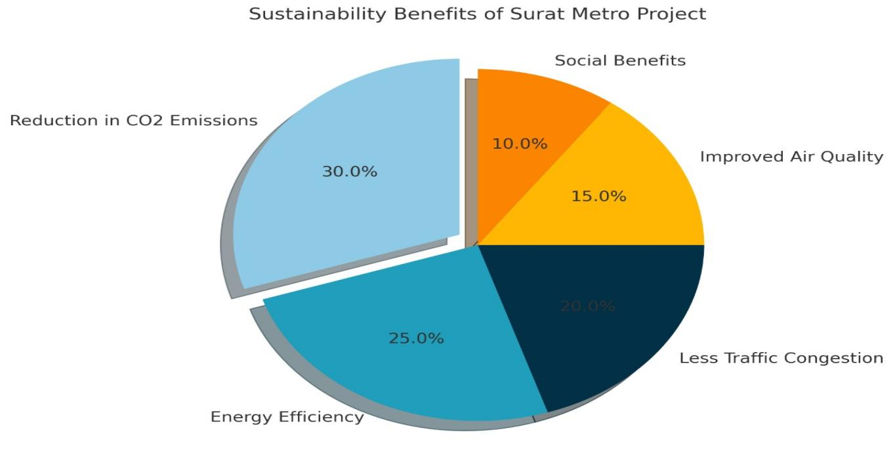

The Sustainability assessment confirms that the Surat Metro is a forward-thinking project that will have lasting positive impacts on the environment, society, and economy. By prioritizing green technologies, social equity, and financial sustainability, the metro system is poised to support Surat’s urban development while promoting a cleaner, more efficient, and inclusive transportation system.

**AFFORDABILITY**

The Affordability section examines the financial accessibility of the Surat Metro project for all segments of the population. The goal is to ensure that the metro system remains an affordable and equitable transportation option for residents, regardless of their socioeconomic status. This section outlines strategies for cost-effective fare structures, financial planning, and strategies to minimize the economic burden on users while ensuring the financial sustainability of the metro system.

**Key Aspects of Affordability**

**1.Affordable Fare Structure**

* **Subsidized Fares for Economically Weaker Sections**: The metro will offer subsidized fares for economically disadvantaged groups, ensuring that those from lower-income backgrounds can still access the system. This will ensure that the metro is accessible to everyone, regardless of their financial capacity.
* **Tiered Fare System**: The metro will implement a tiered fare system, where ticket prices are determined based on the distance traveled. This approach ensures that shorter trips are more affordable, while long-distance commuters are charged accordingly, making it equitable for all passengers.

**2.Low Operational and Maintenance Costs**

* **Efficient System Design:** The metro system will be designed to minimize operational and maintenance costs, including energy-efficient trains, smart ticketing systems, and optimized train schedules. These efficiencies will help lower the overall operating costs, allowing the system to remain affordable while maintaining high service standards.
* **Revenue from Commercial Development:** Revenue generated from commercial ventures around metro stations (such as retail spaces, advertising, and leasing opportunities) will help offset operational costs and contribute to keeping ticket prices affordable for passengers.

**3.High Ridership for Revenue Generation**

* **Encouraging Ridership:** The affordability of fares, combined with the metro’s efficiency and connectivity, is expected to encourage high ridership, which in turn will generate sufficient revenue to support the system’s operations. The goal is to ensure a high number of daily passengers, thereby reducing the financial burden on the government or public subsidies.
* **Attracting Passengers:** By offering a reliable, efficient, and affordable transportation option, the metro is expected to capture a significant share of commuters who currently rely on private vehicles or crowded public transport options, further supporting revenue generation.

**4.Funding Strategies and Financial Planning**

* **Government Funding and Public-Private Partnerships (PPPs):** The project will receive initial funding from the government and through public-private partnerships. These funds will help minimize the upfront costs of construction and make the system financially feasible in the long term.
* **Long-Term Financial Sustainability:** A key aspect of the metro’s affordability is ensuring that it remains financially sustainable in the long term. This involves careful financial planning, including setting realistic fare levels, securing funding for future expansions, and ensuring that the metro can operate without relying excessively on public subsidies.

**5.Ticket Price Comparisons**

* **Cost Comparison with Other Modes of Transport:** The metro’s fare structure will be competitive with other public transport options, such as buses and auto-rickshaws. By providing a more affordable and efficient alternative to private car usage, the metro will encourage commuters to use it instead of more expensive modes of transport.

**Outcome of Affordability Analysis**

* **Equitable Access:** The metro’s subsidized fares and tiered pricing structure ensure that all residents, including those from lower-income households, will have access to affordable and reliable public transport.
* **Sustainable Revenue Model:** The combination of affordable fares, high ridership, and revenue from commercial ventures ensures that the metro will remain financially sustainable over time.
* **Cost-Effective Transportation:** By offering a more affordable and efficient alternative to private vehicles, the metro will reduce the economic burden on families and businesses while improving overall urban mobility.

**Visual Representation**

* **Fare Structure Diagram:** A diagram illustrating the tiered fare system, showing the different price points based on distance and the subsidy offered to economically weaker sections.
* **Revenue and Cost Distribution Pie Chart:** A pie chart showing the distribution of the metro's revenue sources (e.g., ticket sales, commercial development) and how these will contribute to maintaining low fares and operational costs.

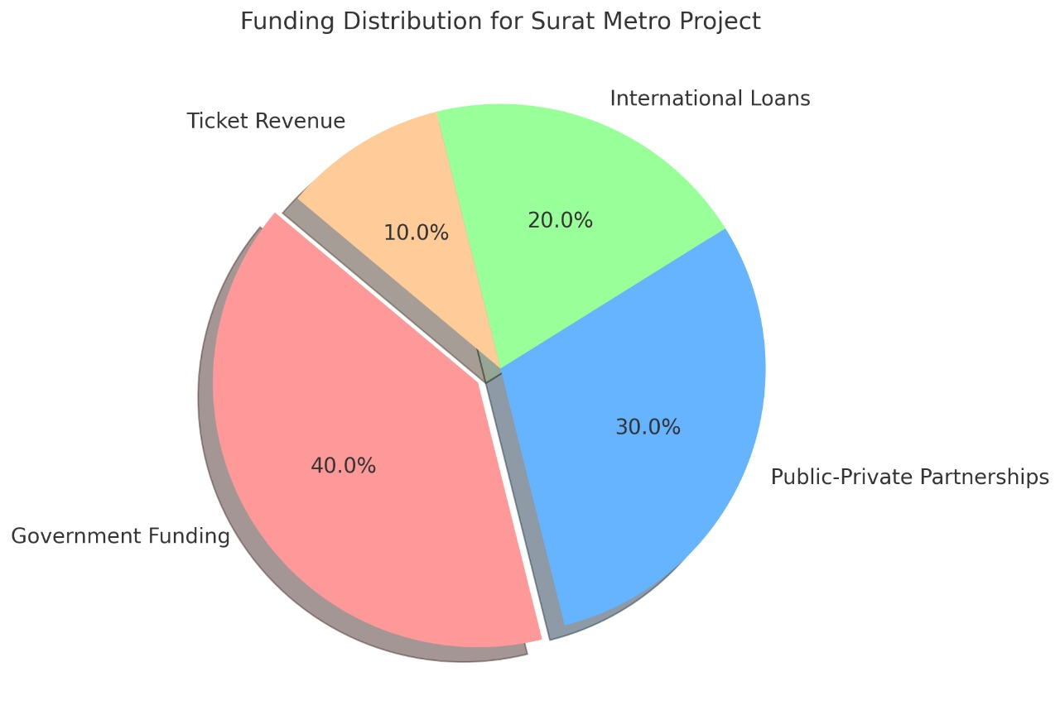

The Affordability analysis demonstrates that the Surat Metro will be both financially accessible to the public and economically viable. With strategies in place to minimize operational costs, ensure high ridership, and provide subsidized fares for disadvantaged groups, the metro system is designed to offer an affordable, sustainable, and equitable transport option for all residents of Surat.

**RESULTS AND DISCUSSIONS**

The Results and Discussions section presents the key findings from the feasibility study of the Surat Metro project. This section outlines the anticipated outcomes of the metro system's implementation, including its impact on traffic congestion, air quality, economic growth, and urban mobility. It also provides insights into the next steps for project expansion and execution.

**Key Results**

**1.Reduction in Traffic Congestion**

* The implementation of the Surat Metro is expected to significantly reduce traffic congestion in the city. By providing a fast, efficient, and reliable mode of public transport, the metro will alleviate pressure on existing road networks.
* The metro system is projected to decrease the number of private vehicles on the road, leading to smoother traffic flow and shorter travel times, particularly during peak hours.
* Key congestion points identified through traffic volume counts (TVC) will be addressed by strategically placing metro corridors along high-traffic routes, especially in areas like Sarthana, Dream City, and Bhesan.

**2.Improvement in Air Quality**

* One of the most significant environmental benefits of the Surat Metro will be the improvement in air quality. By reducing the reliance on private vehicles and promoting the use of electric-powered trains, the metro will help cut down vehicular emissions and reduce pollution levels in Surat.
* A decrease in air pollutants like nitrogen oxides (NOx) and particulate matter (PM) will contribute to better public health outcomes, making the city more livable for its residents.

**3.Increased Economic Opportunities**

* The metro is expected to drive economic growth by improving access to businesses, markets, and services. Better connectivity will allow workers to travel more efficiently to their workplaces, reducing lost productivity due to traffic delays.
* The construction and operational phases of the metro will create thousands of jobs, both directly (in construction, operations, and management) and indirectly (in retail, security, and service sectors surrounding metro stations).
* Increased property values around metro stations are anticipated, which will further contribute to the economic growth of Surat.

**4.Social Benefits**

* The metro will provide enhanced accessibility to public transport, particularly for residents in underserved and peripheral areas of the city. The project is expected to increase public transport coverage from 50% to 90% of the population.
* The metro will also provide a safer, more reliable alternative to overcrowded buses and other forms of public transport. Commuters will benefit from reduced travel times, improved comfort, and the reliability of metro services.
* The reduction in private car usage and the improved safety of public transport will contribute to fewer road accidents, promoting safer urban mobility.

**5.Sustainability and Environmental Impact**

* The metro system will play a crucial role in reducing Surat’s carbon footprint. With the use of solar energy, energy-efficient technologies, and reduced reliance on fossil fuels, the metro will be a cornerstone of the city’s long-term sustainability goals.
* By providing a cleaner and more efficient transportation option, the metro will contribute to Surat's efforts to mitigate climate change and reduce pollution levels.

**Discussions**

**1.Need for Expansion**

* Given Surat’s rapid population growth and urban expansion, the metro network will need to be expanded in the future. The initial phase of the metro focuses on connecting key areas of the city, but as the population continues to grow, additional corridors and stations will be necessary.
* The continued development of the metro system will help address future transportation demands and further reduce congestion as the city grows beyond its current infrastructure capacity.

**2.Phased Execution**

* The implementation of Phase 1, which covers the Sarthana-Dream City and Bhesan-Saroli corridors, is just the beginning. Future phases will need to consider further integration of the metro with other transportation systems, such as buses and cycling networks.
* A detailed project report (DPR) for Phase 2 can be developed once Phase 1 is under construction, ensuring that the project team can continue its work seamlessly.

**3.Challenges in Implementation**

* One of the challenges in metro implementation is managing land acquisition and ensuring fair compensation for those displaced by the construction of stations and tracks. The project team must work closely with local communities and regulatory bodies to mitigate displacement and ensure that the benefits of the metro system are distributed equitably.
* Another challenge will be ensuring that the metro fares remain affordable while maintaining the financial sustainability of the system. Balancing fare affordability with operational costs is crucial to ensure that the metro remains accessible to all residents of Surat.

**4.Potential for Future Growth**

* The metro is designed to serve as a foundation for Surat’s future public transportation needs. By addressing current congestion and pollution issues, it lays the groundwork for a more sustainable and integrated urban transport system.
* Future metro extensions and the integration of metro services with other modes of transport (such as buses, taxis, and bike-sharing systems) will help create a seamless, multi-modal transport network in Surat.

The Results and Discussions section demonstrates that the Surat Metro project will bring substantial benefits to the city, including reduced traffic congestion, improved air quality, increased economic opportunities, and enhanced social inclusion. However, challenges remain, particularly in terms of expanding the network to meet future demand and ensuring the affordability and sustainability of the metro system. Nonetheless, the metro is positioned to significantly transform Surat’s urban mobility landscape in the years to come.

**CONCLUDING REMARKS**

The Surat Metro project represents a transformative step in addressing the city's pressing urban transportation challenges. With a rapidly growing population and increasing urbanization, Surat has faced significant issues related to traffic congestion, pollution, and inadequate public transportation infrastructure. The feasibility study has comprehensively evaluated the project's potential to address these challenges, highlighting its technical, economic, environmental, and social benefits.

**Key Findings**

**1.Sustainability and Environmental Benefits:**

* The metro system is expected to significantly reduce traffic congestion, leading to smoother traffic flow and shorter travel times. This will have a direct positive impact on air quality, contributing to a cleaner and healthier environment.
* Energy-efficient technologies and the integration of solar power will ensure that the metro operates sustainably, reducing the city's carbon footprint and promoting long-term environmental sustainability.

**2.Economic and Social Benefits:**

* The project is economically viable, with a high Economic Internal Rate of Return (EIRR) of 17.20%, demonstrating strong long-term benefits for the city's economy. The metro will create thousands of jobs, both during construction and in the operational phase, boosting employment and economic activity.
* Socially, the metro will increase accessibility to reliable public transportation, especially for underserved areas. It will provide a safer, more efficient mode of transport for all residents, improving quality of life and promoting social equity.

**3.Long-Term Viability:**

* The metro system is designed to be financially sustainable through a combination of government funding, public-private partnerships, and revenue generated from ticket sales and commercial development around metro stations. The affordability of fares, coupled with high ridership, will ensure the system's economic sustainability.
* The metro's integration with existing transport systems and its expansion plans will ensure that Surat’s public transport network can meet the city's future needs.

**Future Prospects**

* **Expansion and Further Development:** The initial phase of the metro project will lay the foundation for future growth. As the city expands, additional metro corridors and stations will be required to meet the growing transportation demand. This phased approach allows for gradual and sustainable growth of the metro system.
* **Integration with Other Transportation Modes:** The long-term success of the metro will depend on its integration with other forms of sustainable transport, such as electric buses, cycling lanes, and shared mobility services. This multi-modal approach will help reduce dependency on private vehicles and further enhance urban mobility.

**Conclusion**

The Surat Metro project is not just a transportation solution but a catalyst for sustainable urban development. By reducing congestion, improving air quality, and providing equitable access to public transport, the metro will contribute to Surat’s transformation into a more livable, accessible, and economically vibrant city. The project is financially sound, environmentally beneficial, and socially inclusive, making it a crucial step toward a sustainable future for Surat.

The Economic Internal Rate of Return (EIRR) of 17.20% clearly demonstrates that the project is well-justified in terms of its social, environmental, and economic benefits, solidifying its role as a critical infrastructure development for Surat’s future.